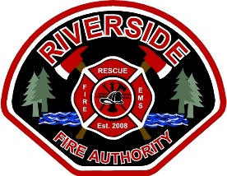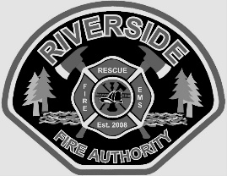EMPLOYMENT OPPORTUNITY

ENTRY-LEVEL Firefighter paramedic

Riverside Fire Authority is recruiting for at least one immediate opening and establishing an eligibility list.

**Rank:** Firefighter/PM **Reports To:** Company Officer **F.L.S.A. Status:** Non-Exempt **Bargaining Unit:**  Local 451

**Salary:** 2025 Salary FF/PM $6,758 - $8,447  **Work Shift**: 4 Platoon - 1 on 3 off , 42 hr work week

**Required Qualifications**

* Must be a citizen of the United States, or eligible to hold employment in the United States.
* Must be able to read, write and speak effectively in English.
* Valid unrestricted driver's license.
* High School Graduate/GED or equivalent.
* Current National Registry or WA State certified Paramedic.
* Must be 21 years of age or older.
* A minimum of two (2) years’ uninterrupted experience working as an EMT-P by application deadline.

**Desired Qualifications**

* IFSAC Firefighter I (must be able to obtain within first 18 months of employment)
* A minimum of one (1) year of uninterrupted full-time fire service experience within the last two (2) years.

**How to Apply:**

Qualified candidates may obtain an application:

Apply by submitting a letter of interest, application, resume, and copies of applicable Fire/EMS certificates, to the RFA Board Secretary at 1818 Harrison Avenue, Centralia, WA 98531. The application form and other documents can be found on our website at [www.riversidefire.net](http://www.riversidefire.net) and click on the Employment link. For additional information contact Stephanie Slorey, at 360-736-3975 or at [sslorey@riversidefire.net](mailto:sslorey@riversidefire.net)

**REQUIRED APPLICATION PACKET CHECKLIST**

* Cover letter with original signature and Resume` (will be graded)
* Completed RFA employment application with original signature (will be graded)
* Copy of Paramedic certification.
* Copy of current driver’s license and Social Security Card.
* Copy of High School Diploma, Equivalent GED or College Transcript.
* Copies of Firefighter and Paramedic training certifications.

**The above materials must be included with your application.** Applications and supplemental information must be received by mail **OR** submitted in person to Station 2-Headquarters (1818 Harrison Ave, Centralia WA) no later than

5:00 PM on June 30, 2025. Late applications will not be accepted. Any application submitted without all items on the Application Packet Checklist will not move forward in the hiring process.

**Military Preference:**

Military preference credit will be awarded in accordance with RCW 41.04. Applicants claiming military preference must attach evidence of their military service (Form DD214 or discharge orders).

The Authority is an equal opportunity employer and is committed to providing equal opportunity and access regardless of race, religion, creed, color, national origin, age, sex, sexual orientation, disabled veteran status, veteran status, physical, mental, or sensory disability. Women, minorities, veterans, and persons with disabilities are encouraged to apply. The Authority will provide reasonable accommodation for persons with disabilities during the selection process, if requested. Please notify the Authority of the accommodation needed, preferably at the time of applying. Only United States citizens and aliens lawfully authorized to work in the United States are eligible for employment. All new employees will be required to complete and sign an Employment Eligibility Verification form and present documentation verifying identity and employment eligibility.