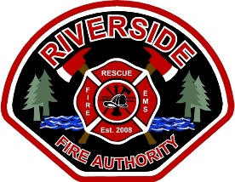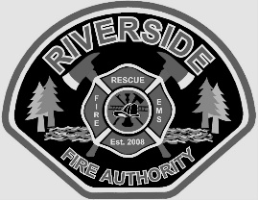EMPLOYMENT OPPORTUNITY

ENTRY-LEVEL Firefighter / EMT

Riverside Fire Authority is recruiting for at least one immediate opening and establishing an eligibility list.

**Rank:** Firefighter/EMT **Reports To:** Company Officer **F.L.S.A. Status:** Non-Exempt **Bargaining Unit:**  Local 451

**Salary:** 2025 Salary FF/EMT $6,143 - $7,679  **Work Shift**: 4 Platoon - 1 on 3 off, 42-hour work week

**Required Employment Qualifications**

* Must be a citizen of the United States, or eligible to hold employment in the United States.
* Must be able to read, write and speak effectively in English.
* Valid unrestricted driver's license that meets RFA and Insurance Carrier requirements.
* High School Graduate/GED or equivalent.
* Current National Registry or WA State certified EMT.
* Must be 21 years of age or older.
* IFSAC FF 1
* A minimum of one (1) uninterrupted year of documented volunteer or paid fire service experience within the last 3 calendar years.

**Desired qualifications**

* IFSAC FF II / NWCG approved Wildland FF II certifications.

**How to Apply:**

Qualified candidates may secure an application:

Apply by submitting a letter of interest, application, resume, and copies of applicable Fire/EMS certificates, to the RFA Board Secretary at 1818 Harrison Avenue, Centralia, WA 98531. The application form and other documents can be found on our website at [www.riversidefire.net](http://www.riversidefire.net) and click on Employment link. For additional information contact Stephanie Slorey, at 360-736-3975 or at [sslorey@riversidefire.net](mailto:sslorey@riversidefire.net)

**REQUIRED APPLICATION PACKET CHECKLIST**

* Cover letter with original signature (will be graded)
* Completed RFA employment application with original signature (will be graded)
* Resume (will be graded)
* Copy of EMT, FF1 and Haz Mat operations and any other pertinent certifications.
* Copy of current driver’s license and Social Security Card.
* Copy of High School Diploma, Equivalent GED or College Transcript.

**The above materials must be included with your application.** Applications and supplemental information must be received by mail **OR** submitted in person to Station 2-Headquarters (1818 Harrison Ave, Centralia WA) no later than

5:00 PM on June 30, 2025. Late applications will not be accepted. Any application submitted without all items on the Application Packet Checklist will not move forward in the hiring process.

**Military Preference:**

Military preference credit will be awarded in accordance with RCW 41.04. Applicants claiming military preference must attach evidence of their military service (Form DD214 or discharge orders).

The Authority is an equal opportunity employer and is committed to providing equal opportunity and access regardless of race, religion, creed, color, national origin, age, sex, sexual orientation, disabled veteran status, veteran status, physical, mental or sensory disability. Women, minorities, veterans, and persons with disabilities are encouraged to apply. The Authority will provide reasonable accommodation for persons with disabilities during the selection process, if requested. Please notify the Authority of the accommodation needed, preferably at the time of applying. Only United States citizens and aliens lawfully authorized to work in the United States are eligible for employment. All new employees will be required to complete and sign an Employment Eligibility Verification form and present documentation verifying identity and employment eligibility.